# Introduction to MapReduce and YARN

## Describe the MapReduce model v1 — this is the “classic” version that comes with Hadoop 1

We start with an Introduction to MapReduce processing based on MapReduce v1. This is the agenda for the first section of this course. It deals with classic MapReduce, now known as MapReduce v1 (MR1

### Principals -spread data and -bring program to data

The driving principal of MapReduce is a simple one:

* spread your data out across a large cluster of machines
* rather than bringing the data to your programs as you do in a traditional programming environment — you write your program in a specific way that allows the program logic to be moved to the data. Thus, the entire cluster is brought to bear in both reading the data as well as processing the data.

### Distributed File System at the heart

A distributed file system — the Hadoop Distributed File System, aka HDFS — is at the heart of MapReduce. It is responsible for spreading data across the cluster, by making the entire cluster look like one giant file system.

When a file is written to the cluster, blocks of the file are spread out and replicated across the whole cluster. In the diagram we can see that every block of the file is replicated to three different nodes, or machines, in a cluster of machines.

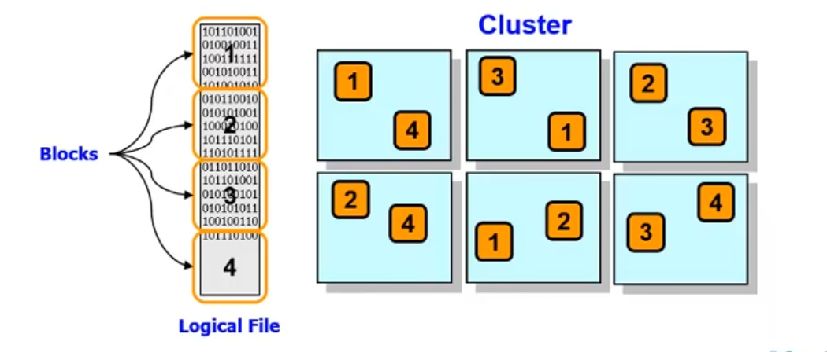

Adding more nodes to the cluster instantly adds capacity to the file system and, as we'll see on the next slide, automatically increases the available processing power and parallelism.

### Two important aspects

#### Software to support distributed computing

MapReduce is a software framework originally introduced by Google to support distributed computing on large data sets held on a cluster of computers.

#### The Hadoop Distributed File System (HDFS) is where Hadoop stores its data.

This file system spans all the nodes in a cluster. Effectively, HDFS links together the data that resides on many local nodes, making the data part of one big file system.

HDFS assumes nodes will fail, so it replicates a given chunk of data across multiple nodes to achieve reliability. The degree of replication can be customized by the Hadoop administrator or programmer. However, the default is to replicate every chunk of data across 3 nodes: 2 on the same rack, and 1 on a different rack.

### MapReduce programming model

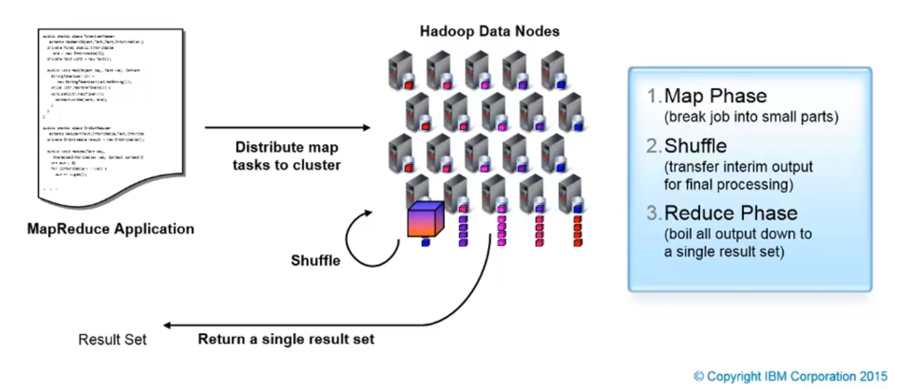

The key to understanding Hadoop lies in the MapReduce programming model. This is essentially a representation of a divide and conquer processing model, where the files input is split into many small pieces (in the map step), and the Hadoop nodes process these pieces in parallel. Once these pieces are processed, the results are distilled (in the reduce step) down to a single set of results.

### MapReduce v1 engine

If one TaskTracker is very slow, it can delay the entire MapReduce job -- especially towards the end of a job, where everything can end up waiting for the slowest task.

#### Master/Slave Architecture

Single master (JobTracker) controls job execution on multiple slaves (TaskTrackers)

#### JobTracker

The JobTracker master node breaks the job up into Map and Reduce steps, finds where the blocks or splits of the input file or files are located, and then assigns work to appropriate worker nodes for Map and Reduce processing.

* Accepts MapReduce jobs submitted by clients
* Pushes map and reduce tasks out to TaskTracker nodes
* Keeps the work ad physically close to data as possible
* Monitors tasks and TaskTracker status

#### TaskTracker

* Runs map and reduce tasks
* Report status to JobTracker
* Manages storage and transmission of intermediate output

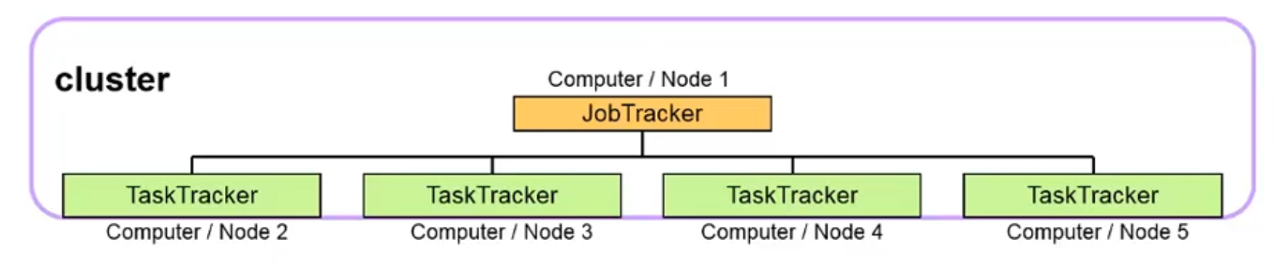

#### Speculative Execution

With speculative execution enabled, however, a single task can be competitively executed on multiple slave nodes in parallel.

#### Scheduling

For jobs scheduling, by default Hadoop uses a FIFO approach (First in, First Out) with five optional scheduling priorities to schedule jobs from a work queue. Other scheduling algorithms are available as add-ins:

* Fair Scheduler
* Capacity Scheduler
* Others

### Map Step

In the "Map" step, each worker node participating in the Mapper process takes its designed block of input, reads it, and then performs the Map processing on it. It produces an output file for each of the Reducers that participate in the follow up step.

* Input is split into pieces (HDFS blocks or “splits”)
* Worker nodes process the individual pieces in parallel (under global control of a Job Tracker)
* Each worker node stores its result in its local file system where a reducer is able to access it

#### Mappers

On a previous slide you saw something to the effect that "if you write your programs in a special way" the programs can be brought to the data. This special way is called MapReduce and involves breaking your program down into two discrete parts: Map and Reduce. Let’s look at the Map Phase first.

A mapper is typically a relatively small program with a simple task: it is responsible for reading a portion of the input data — one block of one file — interpreting, filtering, or transforming the data as necessary and then finally producing a stream of <key, value> pairs.

What these keys and values are doesn't really matter for this discussion, but just keep in mind that these <key, value> pairs don't have to be simple values. They can be as large and as complex as you need for the job at hand.

* Small program (typically), distributed across the cluster, local to data
* Handed a portion of the input data (called a split)
* Each mapper parses, filters, or transforms its input
* Produced key value pairs

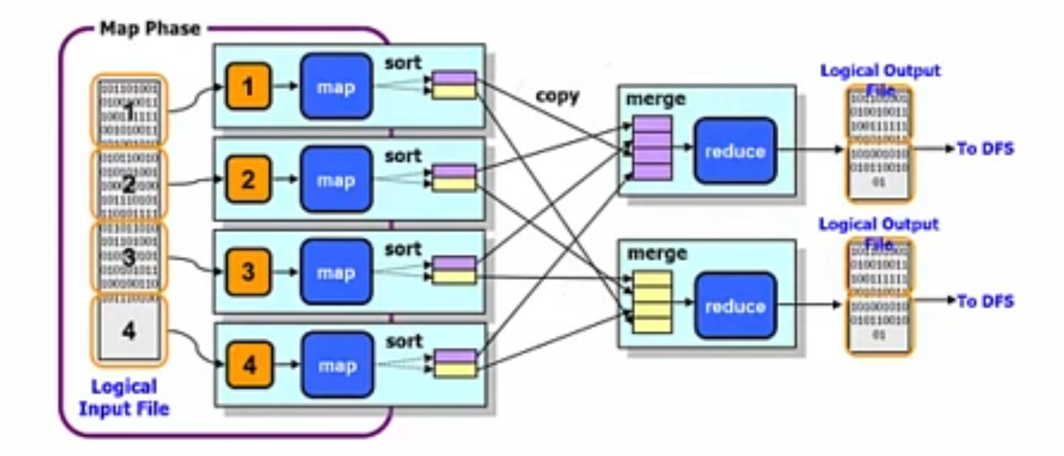

As shown in the diagram, the MapReduce environment automatically takes care of your small "map"

program (the blue boxes on the left) and pushing that program out to every machine that has a block of

the file that you will be processing. This means that the bigger the file, the bigger the cluster, more

mappers get involved in processing the data! *That's a powerful idea.*

### Shuffle Step

* The output of each mapper is locally grouped together by key
* One node is chosen to process data for each unique key
* All this movement (shuffle) of data is transparently orchestrated by MapReduce

This next phase is called **Shuffle** and is orchestrated behind the scenes by the underlying MapReduce logic embedded in Hadoop.

The idea here is that all the data that is being emitted from the mappers is first locally grouped by the **<key>** that your program chose, and then for each unique key, a node is chosen to process all values from all the mappers for that key.

For example, let say you used U.S. state (e.g. "MA", "AK", "NY", "CA", etc.) as the key of your data, then one machine would be chosen to send all of the California data to, one all of the New York data, and so on.

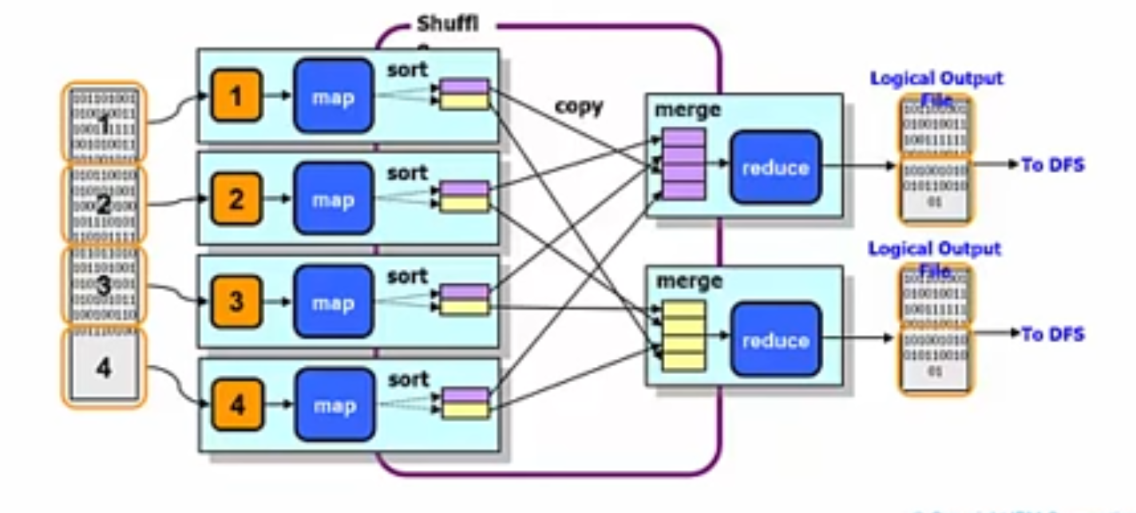

Each machine would be responsible for processing the data for its *selected* state or states. In the picture above, Hadoop has decided that only two sets of keys (yellow and purple) are needed, but keep in mind that there may be many, many records with the same key (or set of keys) coming from a given mapper.

### Reduce Step

In the "Reduce" step, the answers to all the sub-problems generated by the Map nodes are sent to a set of Reduce nodes where they are combined or aggregated in some way to produce the final output — the results of the problem MapReduce were originally asked to solve.

* Data is aggregated (“reduced” from the map steps) by worker nodes (under the control of the Job Tracker)
* Multiple reduce tasks parallelize the aggregation
* Output is stored in the HDFS (and thus replicated)

#### Reducers

* Small programs (typically) that aggregate all the values for the key that they are responsible for
* Each reducer writes outputs to its own file

Reducers are the last major part of the picture. Again, reducers are small programs (well, typically small) that are responsible for sorting and/or aggregating or reducing over the values associated with the key (or keys) assigned to the reducer node. Just like with mappers, when a larger number of reducers are used, the more parallelism that can be provided.

Once each reducer has completed whatever it is assigned to do – maybe, for example, add up the total sales for the state (or states) it was assigned – it, in turn, emits key/value pairs that get written to HDFS disk and, in turn, be used as the input to, perhaps, another MapReduce job.

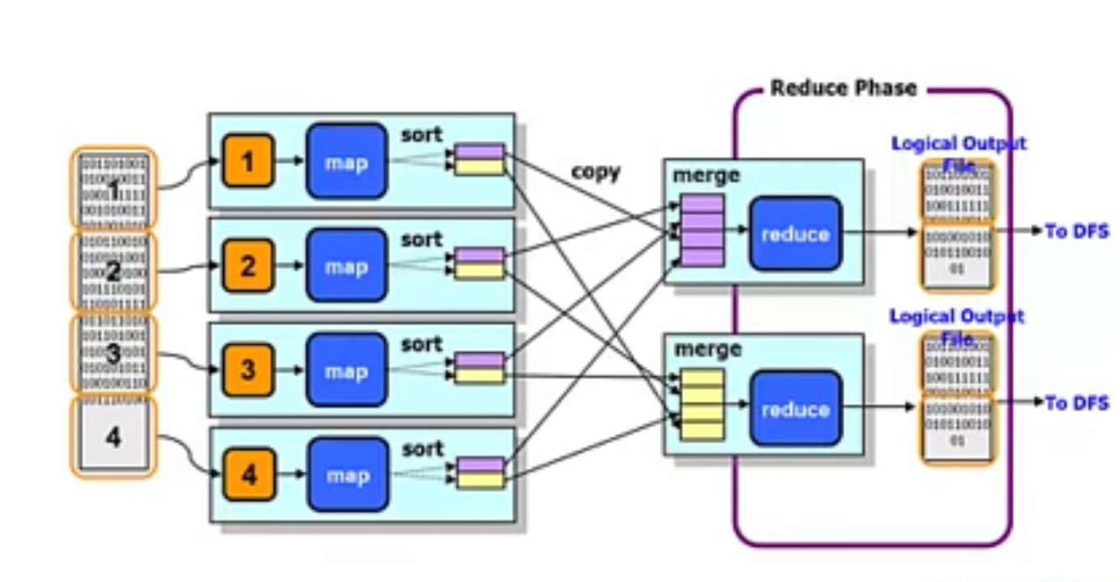

### Combiner

* The data that will go to each reduce node is sorted and merged before going to the reduce node
* Pre doing some work of the receiving reduce node to minimize network traffic between map and reduce nodes

Q) Which of the following is the correct sequence of MapReduce flow?

* Reduce —> Combine —> Map
* Combine —> Reduce —> Map
* Map —> Reduce —> Combine
* Map —> Combine —> Reduce

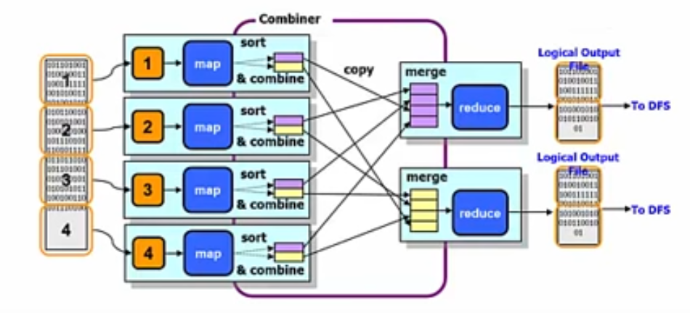

At the same time as the *sort* is done during the Shuffle work on the Mapper node, an *optional* **Combiner** function may be applied.

For each key set, all key/values with that key set will be sent to the same Reducer node — that is the purpose of the Shuffle phase.

Rather than sending multiple key/value pairs with the same key value to the Reducer node, the values are *combined* into one key/value pair. This is only possible where the reduce function is additive (that is, does not lose information when combined).

Since only one key/value pair is sent, the file transferred from Mapper node to Reducer node is smaller and network traffic is minimalized.

### API vs Execution Environment

The slide shows the execution environment and describes the Application Programming Interfaces (APIs) that are used. We will see that a similar, and somewhat compatible, API environment is used for both MapReduce 1 and for YARN/MapReduce 2.

* APIs are implemented by applications and are largely independent of execution environment
* Execution environment defines how MapReduce jobs are executed

#### MapReduce APIs

* Org.apache.mapred
  + Old API largely superseded some classes still used in new API
  + Not changed with YARN
* Org.apache.mapreduce
  + New API, more flexible, widely used
  + Applications may have to be recompiled to use YARN (not binary compatible)

#### Execution Environments

* Classic JobTracker/TaskTracker from Hadoop v1
* YARN (MapReduce v2): Flexible execution environment to run MapReduce and much more
  + No single JobTracker, instead ApplicationMaster jobs for every application

### Phases

* Map (Major)
* Shuffle (Minor)
* Reduce (Major)
* Combine (Minor)

Q) Which of the following is the correct sequence of MapReduce flow?

* Reduce —> Combine —> Map
* Combine —> Reduce —> Map
* Map —> Reduce —> Combine
* Map —> Combine —> Reduce

### MapReduce 1 overview

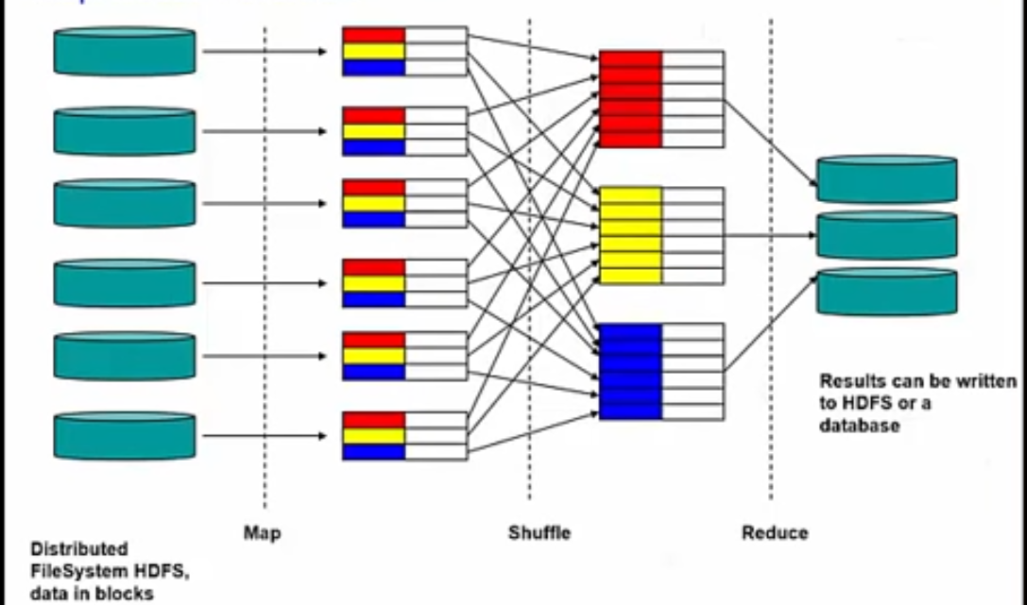

File blocks (stored on different DataNodes) in HDFS are read and processed by Map tasks running on the

DataNodes where the blocks of data are stored.

The output of the Map tasks is shuffled, then sent to the Reducer tasks (one output file from *each*

Mapper task to *each* of the Reducer tasks) — the files exchanged here are not replicated and are

temporarily stored local to the Mapper node.

The Reducers produces the output, and that output is stored in HDFS, with one file for each Reducer, and replicated.

## List the limitations of both Hadoop 1 and MapReduce 1

Note the following shortcomings of the *standard* code:

* No lowercasing is done, thus **The** and **the** are treated as separate words that will be counted separately
* Any adjacent punctuation is appended to the word, thus **“the** and **the** will be counted separately, and any word followed by punctuation, e.g., **cow,** is counted separately from **cow** (the same word without trailing punctuation)

We will see these shortcomings in the output.

## Review the Java code required to handle the Mapper class, the Reducer class, and the program driver needed to access MapReduce

### Word Count

We have a file, that for simplicity here, has two blocks (or “splits) of data, that lists animal names. There is one animal per line in the files.

* MapReduce can automatically split files on line breaks
* Our file has been split into two blocks on two nodes

We want to count the number of mentions of each animal, but we are interested only in members of the **cat** family.

Since the blocks are held on different nodes, software running on the individual nodes process the blocks separately.

*If* we were using SQL — *which we are not* — the SQL would be as shown.

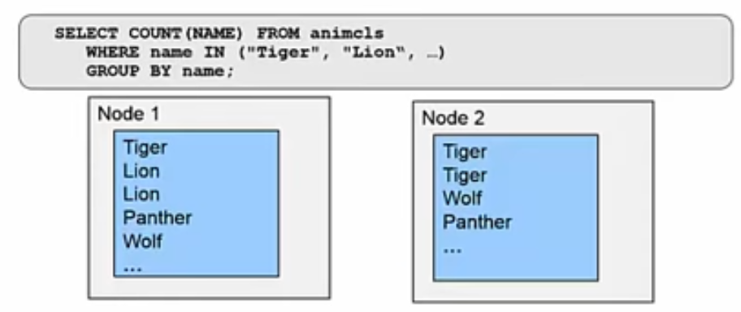

### Map task

* Requirements
  + Filter out the non-big cat rows
  + Prepare count by transforming to <Text (name), Integer (1)>
* The Map step shown on this slide does the following processing:
* *Each* Map node reads *its own* “split” (or block) of data
* The information required — in this case, the names of animals — is extracted from each record — in this case, one line = one record
* Data is filtered — we keep only the names of cat family animals (“Wolf” is eliminated)
* Key-value pairs are created — n this case, key = animal & value = 1
* The key-value pairs are accumulated into locally stored files on the individual nodes where the Map task is being executed

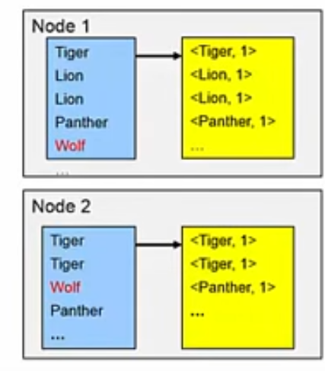

### Shuffle Task

* Shuffle moves all values of one key to the same target node
* Distributed by a Partitioner class (normally hash distribution)
* Reduce tasks can run on any node – here on Nodes 1 and 3
  + The number of map and reduce tasks do not need to be identical
  + Differences are handled by the hash partitioner

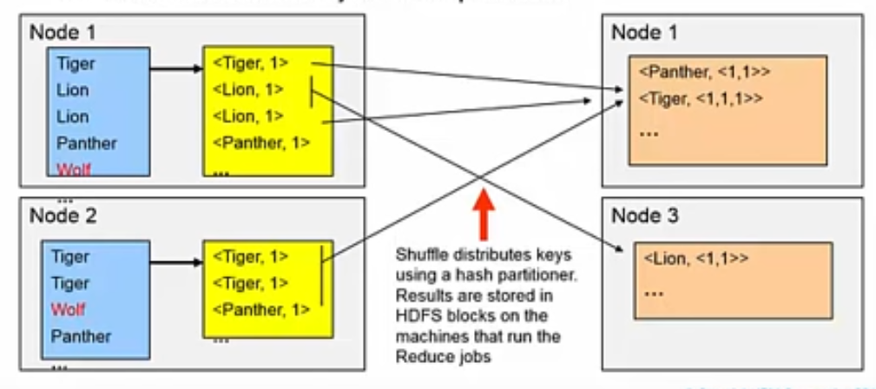

Each Mapper task produces *one file* for *each* Reducer task. A hash function running on the Mapper node determines which Reducer task will receive any key-value pair. All key-value pairs with a particular key will be sent to the same Reducer task.

Reduce tasks can run on any node, either different from the set of nodes where the Map task run or on the same DataNodes. Here we show that Node 1 is used for one Reduce task, but a new node, Node 3, is used for a second Reduce node.

There is no relation between the number of Map tasks — which is, generally, one node for each block of the file(s) begin read — and the number of Reduce tasks.

Commonly the number of Reduce tasks is smaller than the number of Map tasks.

### Reducer Task

* The reduce task computes aggregated values for each key
* Normally the output is written to the DFS
* Default is one output part-file per Reduce task
* Reduce tasks aggregate all values of a specific key – our case, the count of the particular animal type

Note that there are two Reducer tasks running — these are running on two separate nodes, Nodes 1 and 3.

The Reduce node takes the answers to all the sub-problems and combines them in some way to get the output — the answer to the problem we were originally trying to solve.

In this case, the Reduce step shown on this slide does the following processing:

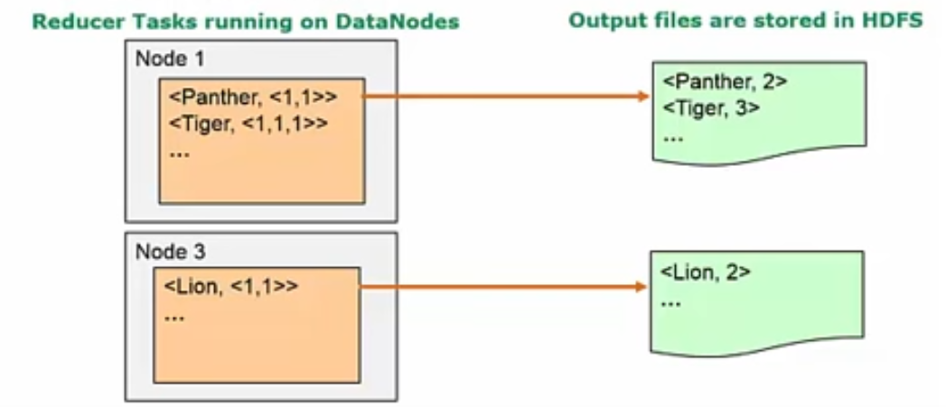

* *Each Reduce node* processes the data sent to it from the various Map nodes
* This data has been previously sorted (and possibly partially merged by Combiner processing)
* The Reduce node aggregates the data — in the case of wordcount, it sums up the counts received for each word — each animal in this case
* One file is produced for each Reduce task and that will is written to HDFS where the output blocks are automatically replicated

### Combiner Task (optional)

* For performance, a pre-aggregate in the Map tasks can be helpful
* Reduces the amount of data sent over the network
  + Also reduces Merge effort, since data is pre-merged in Map
  + Done in the Map task, before Shuffle task

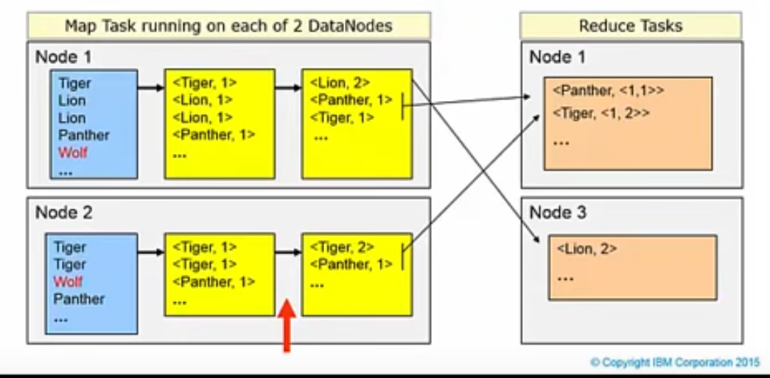

The Combiner step is optional.

When it is used, it runs on a Mapper node and preprocess the intermediate data files on the individual Mapper node which will be sent to Reduce tasks. It pre-merges and pre-aggregates the data in the files that will be transmitted to the Reduce tasks.

The Combiner thus reduces the amount of data that will be sent to the Reducer tasks — and that speeds up the processing as smaller files need to be transmitted from the Mapper nodes to the Reducer nodes.

### JAVA

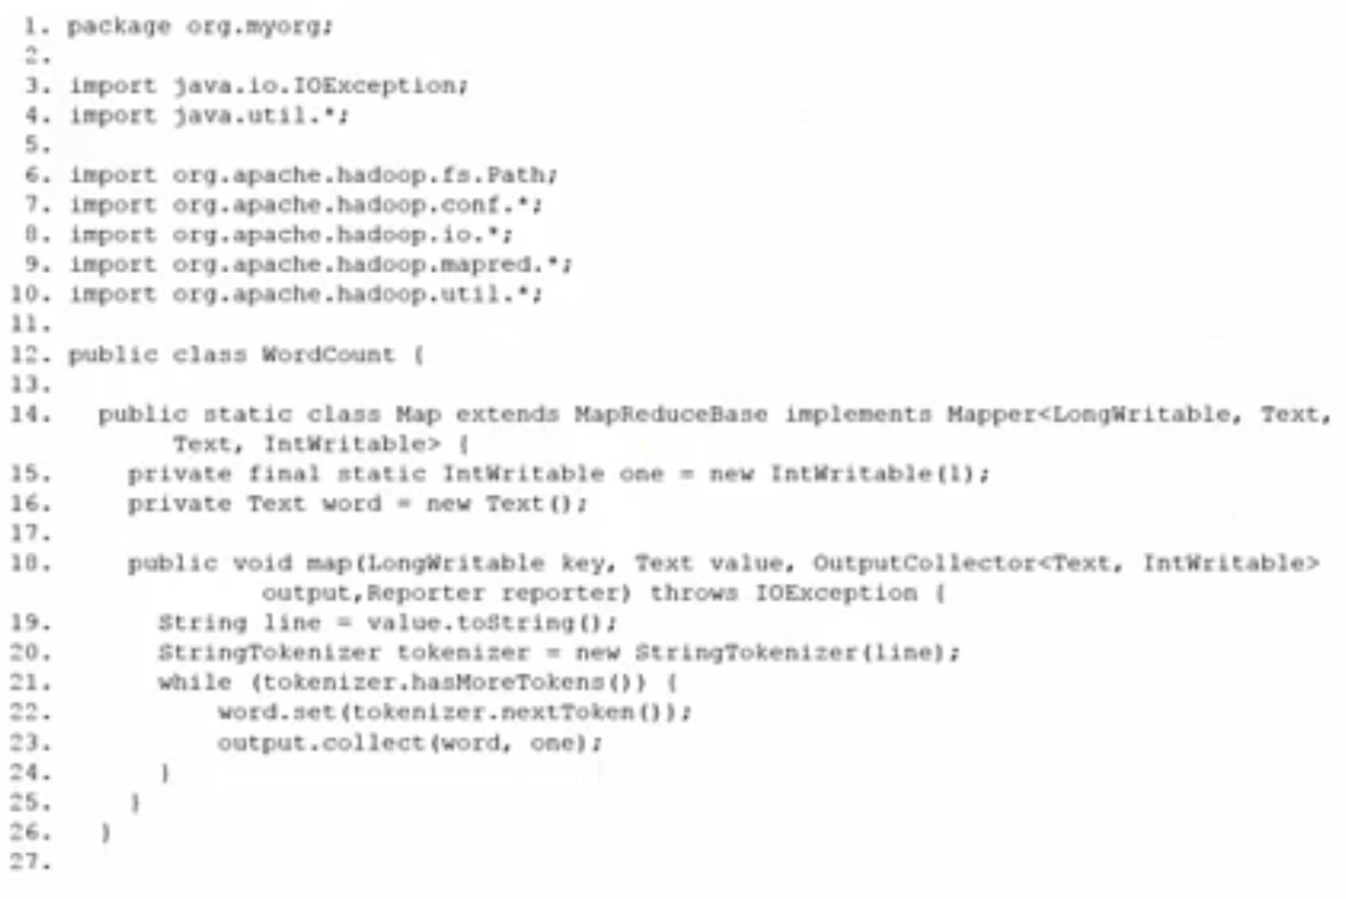

This is a slightly simplified version of WordCount.java for MapReduce 1. The full program is slightly larger, and there are some recommended differences for compiling for MapReduce 2 with Hadoop 2.

Code from the Hadoop classes is brought in with the *import* statements at the top of this page of code. Like an iceberg, most of the actual code executed at runtime is hidden from the programmer — it runs deep down inside Hadoop itself.

#### Map

Our interest here is the Mapper class, **Map**.

This class reads the file — we will see the file name on the driver class that two slides later is passed as arg[0], a string.

Each input record, or line, from the file is read as a string and the string is tokenized, that is, broken into words separated by space(s).

Note the following shortcomings of the *standard* code:

* No lowercasing is done, thus **The** and **the** are treated as separate words that will be counted separately
* Any adjacent punctuation is appended to the word, thus **“the** and **the** will be counted separately, and any word followed by punctuation, e.g., **cow,** is counted separately from **cow** (the same word without trailing punctuation)

We will see these shortcomings in the output. But, note that this is the standard *wordcount* program and we are less interested in the actual results but only in the process at this stage.

The program, *wordcount* is to Hadoop Java programs functions as the *“Hello, world!”* program does to the C language. It is generally the first program that people experience when coming to the new technology.

#### Reduce

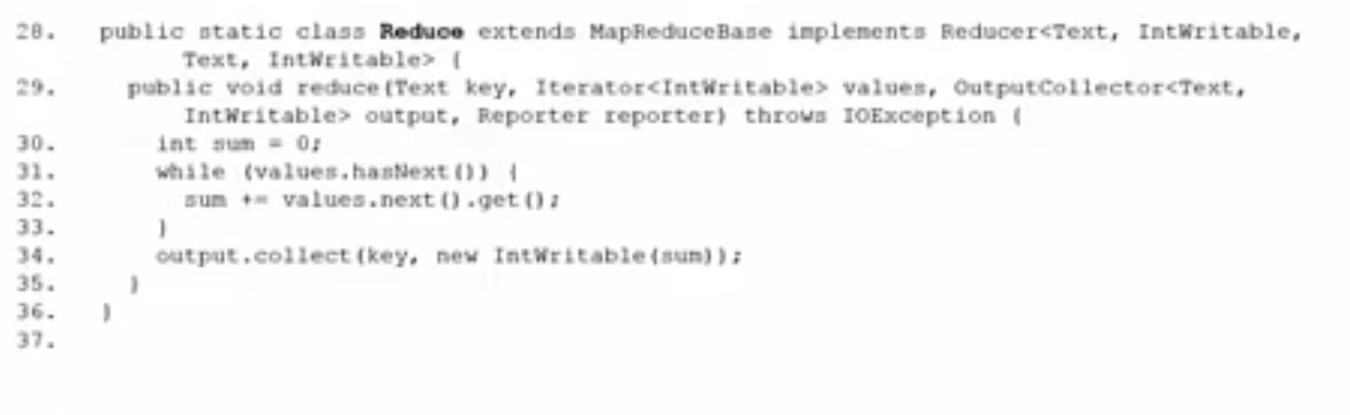

The Reducer class, **Reduce**, is shown here.

The key-value pairs arrive at this class already sorted; courtesy of the core Hadoop classes that we do not see.

Thus, adjacent records will have the same key. While the key does not change, the values are aggregated — in this case, summed with **sum += …**

#### Driver

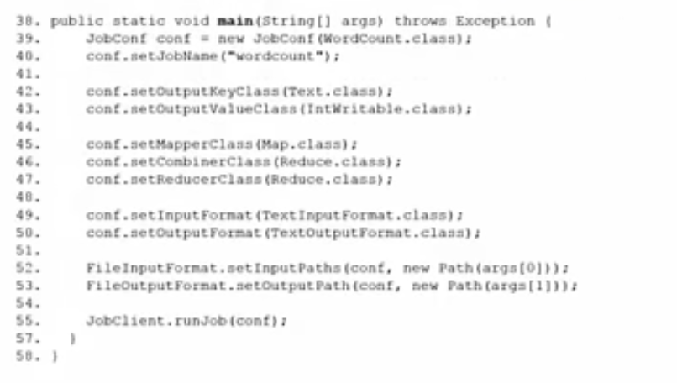

The driver routine, embedded in main, does the following work:

* Sets the JobName for runtime
* Sets the Mapper class to Map
* Sets the Reducer class to Reduce
* Sets the Combiner class to Reduce
* Sets the input file to arg[0]
* Sets the output directory to arg[1]

Note that the Combiner runs on the Map task and use the same code as the Reducer task.

The names of the output files will be generated inside the Hadoop code.

## Describe the YARN model, including the features of YARN and how a YARN program is run

### MapReduce Jobs

#### Client

Submits MapReduce jobs

#### JobTracker

Coordinates the job run, breaks down the job to map and reduce tasks for each node to work on the cluster

#### TaskTracker

Execute the Map and Reduce task functions

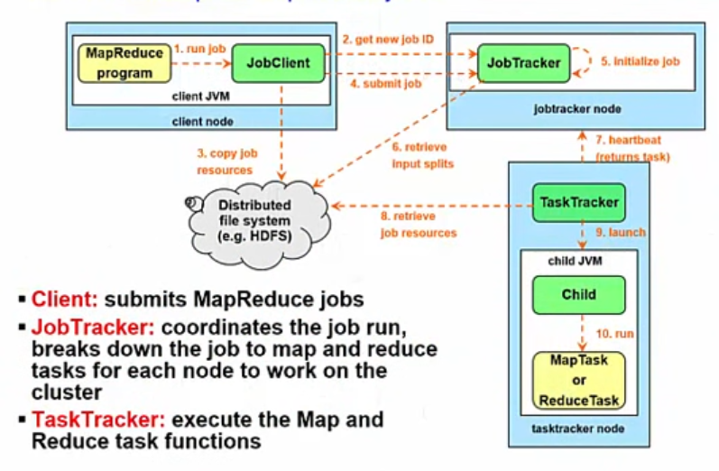

#### 10 steps

The process of running a MapReduce job on Hadoop consists of 10 major steps.

1. The first step is the MapReduce program you've written tells the Job Client to run a MapReduce job.
2. This sends a message to the JobTracker which produces a unique ID for the job.
3. The Job Client copies job resources, such as a jar file containing Java code you have written to implement the map or the reduce task, to the shared file system, usually HDFS.
4. Once the resources are in HDFS, the Job Client can tell the JobTracker to start the job.
5. The JobTracker does its own initialization for the job. It calculates how to split the data so that it can send each "split" to a different mapper process to maximize throughput.
6. It retrieves these "input splits" from the distributed file system, *not the data itself*.
7. The TaskTrackers are continually sending heartbeat messages to the JobTracker. Now that the JobTracker has work for them, it will return a map task or a reduce task as a response to the heartbeat.
8. The TaskTrackers need to obtain the code to execute, so they get it from the shared file system.
9. Then they can launch a Java Virtual Machine with a child process running in it, and
10. This child process runs your map code or your reduce code.

The results of the map operation are stored on local disk without replication for a given TaskTracker node (and, thus, not in HDFS).

The results of the reduce operation are stored to HDFS with standard replication.

### Classes

The InputSplitter, RecordSplitter, and InputFormat classes are found inside the Hadoop code.

#### InputSplitter

divides a file into splits

* Splits are normally the block size but depends on the number of requested Map Tasks, whether any compression allows splitting etc.

#### RecordReader

takes a split and reads the files as a sequence of records

* Ex: one record per line (LineRecordReader)
* Note: A record can be split across splits

#### InputFormat

takes each record and transforms it into **<key, value>** pair(s) that is then passed to the Map task

#### Additional

Other helper classes are needed to support Java MapReduce programs. Some of these are provided from inside the Hadoop code itself, but Hadoop distribution vendors and end-user programmers can provide other classes that either override or supplement the standard code.

Thus IBM provides the LZO compressions algorithm to *supplement* standard compression codecs (e.g., codecs for bzip2, etc.).

### Splits

* Files are stored as “splits” or blocks, with a default size of 128 MB, in most versions of Hadoop these days.
  + Each split or block is processed on the actual DataNode, where it is stored, by a Mapper task running on that node.
* MapReduce divides data into fragments or splits
  + One map task is executed on each split
* Most Files have records with defined split points
  + Most common is the end of the line character
* The InputSplitter class is responsible for taking a HDFS file and transforming it into splits
  + Aim is to process as much data as possible locally

### RecordReader

* Moat of the time a split will not happened at a block end
* Files are read into Records by the RecordReader class
  + Normally the RecordReader will start and stop at the split points
* LineRecordReader will read over the end of the split till the line end
  + HDFS will send the missing piece of the last record over the network
* Likewise, LineRecordReader for Block2 will disregard the first incomplete line

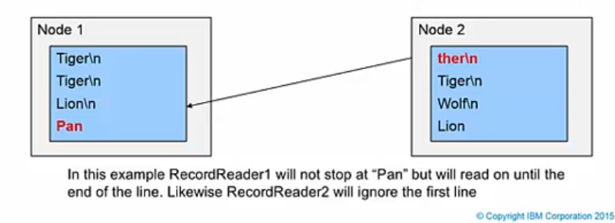

Generally, because the file splits or blocks are a fixed size, most of the time a record (or line) *will* end up broken across blocks.

In the example illustrated, the record with the word “Panther” is broken across blocks, “Pan” is in one block, and the continuation, “ther” followed by newline, or record terminator, in the next block.

The **LineRecordReader** code inside Hadoop is designed to correct this situation so that the complete word, “Panther,” is processed accurately on *just one* of these nodes.

### InputFormat

* MapReduce tasks read files by defining an InputFormat class
  + Map tasks expect <key, value> pairs
* To read line-delimited text files Hadoop provide the TextInputFormat class
  + It returns one key value pair per line in the text
  + The value is the content of the line
  + The key is the character offset to the new line character (end of line)

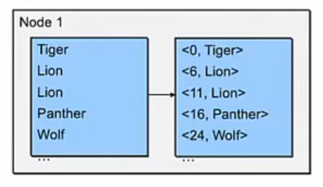

The **InputFormat** class describes the input-specification for a Map-Reduce job.

The Map-Reduce framework relies on the InputFormat of the job to:

* Validate the input-specification of the job.
* Split-up the input file(s) into logical InputSplits, each of which is then assigned to an individual Mapper.
* Provide the RecordReader implementation to be used to glean input records from the logical InputSplit for processing by the Mapper.

The default behavior of file based InputFormat classes, typically sub-classes of FileInputFormat, is to split the input into logical InputSplits based on the total size, in bytes, of the input files. However, the FileSystem block size of the input files is treated as an upper bound for input splits. A lower bound on the split size can be set by a configuration parameter for Hadoop / MapReduce.

Clearly, logical splits based on input-size are insufficient for many applications since record boundaries must be respected. In such cases, the application must also implement a **RecordReader** class that has

the responsibility to *respect* record-boundaries and present a record-oriented view of the logical InputSplit to the processing.

### Failures

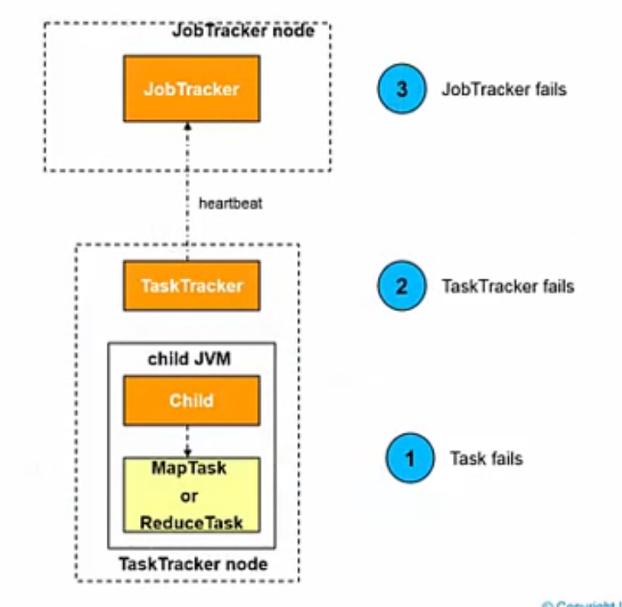

Now that you know what a successful MapReduce job looks like, let us see what happens when something goes wrong.

Failures can happen

1. at the lowest level, the task level (1)
2. or at the TaskTracker level (2)
3. or the JobTracker level (3)

The primary way that Hadoop achieves fault tolerance is through restarting tasks. Individual task nodes (**TaskTrackers**, plural) are in constant communication with *the* head node of the system, called the **JobTracker** (singular). If a TaskTracker fails to communicate with the JobTracker for a period (by default, 1 minute), the JobTracker will assume that the TaskTracker in question has crashed. The JobTracker knows which map and reduce tasks were assigned to each TaskTracker.

#### Mapping Phase

If the job is still in the mapping phase, then other TaskTrackers will be asked to re-execute all map tasks previously run by the failed TaskTracker. If the job is in the reducing phase, then other TaskTrackers will re-execute all reduce tasks that were in progress on the failed TaskTracker.

#### Reduce tasks

Reduce tasks, once completed, have been written their output to HDFS. Thus, if a TaskTracker has already completed two out of three reduce tasks assigned to it, only the third task must be executed elsewhere.

#### Map tasks

Map tasks are slightly more complicated: even if a node has completed ten map tasks, the reducers may not have all copied their inputs from the output of those map tasks. If a node has crashed, then its mapper outputs are inaccessible. So, any already-completed map tasks must be re-executed to make their results available to the rest of the reducing machines. All of this is handled automatically by the Hadoop platform.

#### Side effect free

This fault tolerance underscores the need for program execution to be side-effect free.

If Mappers and Reducers had individual identities and communicated with one another or the outside world, then restarting a task would require the other nodes to communicate with the new instances of the map and reduce tasks, and the re-executed tasks would need to reestablish their intermediate state. This process is notoriously complicated and error-prone in the general case.

MapReduce simplifies this problem drastically by eliminating task identities or the ability for task partitions to communicate with one another. An individual task sees only its own direct inputs and knows only its own outputs, to make this failure and restart process clean and dependable.

# Issues with/Limitations of Hadoop v1 & MapReduce v1

The original Hadoop and MapReduce (v1) had limitations, and several issues have surfaced over time. We will look at what these were, in preparation for looking at the differences and changes introduced with Hadoop 2 and MapReduce v2.

## Compare “YARN / Hadoop 2 / MR2” versus “Hadoop 1 with MR1”

### Only 1 Job Tracker

* Centralized handling of job control flow
* Tight coupling of a specific programming model with the resource management infrastructure
* Hadoop is now being used for all kinds of tasks beyond its original design

The first issue to note is that in the original paradigm: there is only one JobTracker. Thus job flow control is centralized, limiting performance at scaled-up operations Since the time when Hadoop and MapReduce were first made available, Hadoop has been called upon for a range of tasks that go beyond the original design.

### The most serious limitations of classic MRv1:

Q) What is an issue or limitation of the original MapReduce v1 paradigm?

* It's not scalable
* It only has one TaskTracker
* It only supports Parquet file types
* It only has one JobTracker

#### Scalability.

#### Resource utilization

#### Support of workloads different from MapReduce

* In MapReduce framework, the job execution is controlled by two types of processes
  + A single master process called JobTracker, which coordinated all jobs running on the cluster and assigns map and reduce tasks to run on the TaskTrackers
  + Several subordinate processes called Task Trackers, which run assigned tasks and periodically report the progress to the JobTracker

### Scalability: busy JobTracker

### Responsibilities:

#### Management of computational resources in the cluster,

* maintaining the list of live nodes
* the list of available and occupied map and reduce slots
* allocating the available slots to appropriate jobs and tasks according to selected scheduling policy,

#### Coordination of all tasks running on a cluster

* instructing TaskTrackers to start map and reduce tasks
* monitoring the execution of the tasks
* restarting failed tasks
* speculatively running slow tasks
* calculating total values of job counters
* etc.

The large number of responsibilities given to a single process caused significant scalability issues, especially on a larger cluster where the JobTracker had to constantly keep track of

* thousands of TaskTrackers
* hundreds of jobs
* tens of thousands of map and reduce tasks.

The image on the slide illustrates the issue. On the other hand, the TaskTrackers — running on the individual worker, data nodes — have an easy time, usually running only a dozen or so map or reduce tasks each that were assigned to them by the hard- working JobTracker.

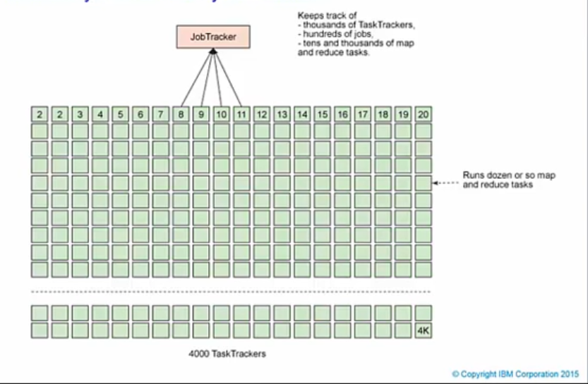

### Yarn /MRv2

* MapReduce has undergone a complete overhaul with YARN, splitting up the two major functionalities of JobTracker (resource management and job scheduling/monitoring) into separate daemons

### Functionality 1 - Resource Management

* ResourceManager (RM) (Global)
  + Data computation framework formed by
    - Global ResourceManager
    - NodeManager (NM), per node slaves
  + Ultimate authority that arbitrates resources among all the applications in the system

### Component 1 – Scheduler

* Responsible for allocating resources to the various running applications subject to familiar constraints of capacities, queues etc.
* Pure scheduler
  + Performs neither monitoring nor tracking of status for the application
  + Offers no guarantees about restarting failed tasks either due to
    - Application failure
    - Hardware failure.
* Schedules based on the resource requirements of the applications
  + based on a resource Container
    - Incorporates elements such as memory, CPU, disk, network etc.
    - In the first (current) version, only memory is supported.
* Policy-plug-in
  + responsible for partitioning the cluster resources among the various queues, applications etc.
  + Ex plugins:
    - CapacityScheduler
      * Supports hierarchical queues to allow for more predictable sharing of cluster resources
    - FairScheduler

### Component 2 – ApplicationsManager

* Responsibilities
  + accepting job-submissions
  + negotiating the first container for executing the application specific ApplicationMaster
  + provides the service for restarting the ApplicationMaster container on failure.

### Functionality 2 - Job Scheduling/Monitoring

Q) A new ApplicationMaster is launched for each job and ends when the job completes. True or False?

* ApplicationMaster (AM) (Per Application)
  + The per-application ApplicationMaster is a framework specific library and is tasked with negotiating resources from the ResourceManager and working with the NodeManagers to execute and monitor tasks
  + An application is either a single job in the classical sense of MapReduce jobs or a directed acyclic graph (DAG) of jobs
* Responsibilities
  + negotiating appropriate resource containers from the Scheduler
  + tracking their status
  + monitoring for progress.

### NodeManager

* per-machine framework agent
* Responsibilities
  + Containers
  + Monitoring their resource usage (CPU, memory, disk, network)
  + Reporting the same to the ResourceManager/Scheduler
* Works with both ApplicationMaster and ResourceManager

. 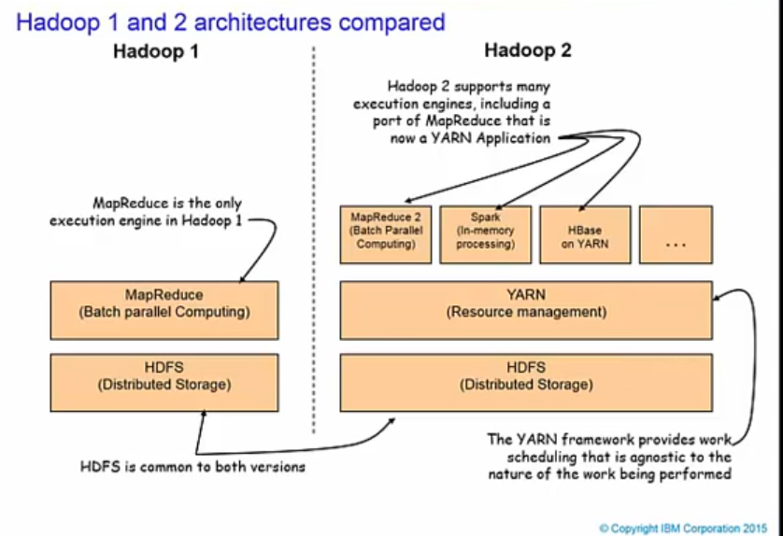

* MRV2 maintains API compatibility with previous stable releases (that is, Hadoop v1).
  + all Map-Reduce jobs should still run unchanged on top of MRv2 with just a recompile.
* Execution engines
  + Hadoop v1: MapReduce
  + Hadoop v2
    - the YARN framework
      * provides work scheduling that is indifferent to the nature of the work being performed. It manages resources at a high level.
    - Spark
      * an in-memory processing engine
    - HBase
    - Etc.

## List the limitations of MapReduce v1 and the need for MR v2 / YARN

Q) How is YARN an improvement over the MapReduce v1 paradigm?

* It's completely open source
* It splits the JobTracker into two processes: ResourceManager and ApplicationManager
* It reduces multi-tenancy to improve performance
* It splits the TaskTracker into two processes: ResourceManager and ApplicationManager

## Describe MR2 / YARN processing

In this video, we will look at YARN features that show why YARN is integral to the future of Hadoop.

* YARN features
  + Scalability
  + Multi-tenancy
  + Compatibility
  + Serviceability
  + Higher cluster utilization
  + Reliability / Availability

### Scalability

* There is one Application Master per job
  + Reason why scales better than previous v1
  + Runs on an arbitrary cluster node and it runs until job reaches termination
* Separation of functionality allows the individual operations to be improved with less effect on other operations
* Supports rolling upgrades without downtime
* ResourceManager focuses exclusively on scheduling allowing clusters to expand to thousands of nodes managing petabytes of data

YARN lifts the scalability ceiling in Hadoop by splitting the roles of the JobTracker from Hadoop v1 into two processes:

#### ResourceManager

that controls access to the clusters resources (memory, CPU, etc.)

#### ApplicationsManager

* (one per job) that controls task execution. Because of this, YARN can run on larger clusters than can MapReduce v1.
* each instance of an application has a dedicated ApplicationMaster, which runs for the duration of the application

MapReduce v1 hits scalability bottlenecks in the region of 4,000 nodes and 40,000 tasks, stemming from the fact that the JobTracker must manage both jobs and tasks.

YARN overcomes these limitations by virtue of its separation of ResourceManager from a per-job ApplicationMaster. This architecture is designed to scale up to 10,000 nodes and 100,000 tasks.

This architectural model is closer to the original Google MapReduce paper, which describes how a master process is started to coordinate map and reduce tasks running on a set of workers.

### Multi-tenancy

* Allows multiple access engines (either open-source or proprietary) to use Hadoop as the common standard for batch, interactive and real-time engines that can simultaneously access the same data sets
* Uses a shared pool of nodes for all jobs
* Allows the allocation of hadoop clusters of fixed size from the shared pool
* Multi-tenent data processing improves an enterprise’s return on its Hadoop investment

a set of features that enable multiple business users and processes to share a common set of resources, such as an Apache Hadoop cluster, via policy, rather than physical separation, yet without negatively impacting service level agreements (SLA), violating security requirements, or even revealing the existence of each other party or job.

* YARN de-couples Hadoop workload management from resource management.
  + multiple applications can share a common infrastructure pool.

Earlier versions of Hadoop consolidated both workload and resource management functions into a single JobTracker. This approach resulted in limitations for consumers hoping to run multiple applications on the same cluster infrastructure.

To borrow from object-oriented programming terminology, multi-tenancy is an “over-loaded” term. It means different things to different people depending on their orientation and context. To say a solution is multi-tenant is not helpful unless we are specific about the meaning. Some interpretations of multi- tenancy in Big Data environments are:

#### Interpretations

* Support for multiple concurrent Hadoop jobs
* Support for multiple lines of business on a shared infrastructure
* Support for multiple application workloads of different types (Hadoop and non-Hadoop)
* Provisions for security isolation between tenants
* Contract-oriented service-level guarantees for tenants
* Support for multiple versions of applications and application frameworks concurrently

Organizations that are sophisticated in their view of multi-tenancy will need all of these capabilities and more. YARN promises to address some of these requirements and does so in large measure. But you will find in future releases of Hadoop that there will be other approaches that will be used to address other forms of and approaches to multi-tenancy. While an important technology, the world is not suffering from a shortage of resource managers. Some Hadoop providers (including IBM) support YARN, while others, for instance, support Apache Mesos.

### Compatibility

* To the end user (a dev not an admin) the changes are invisible
* Possible to run unmodified MapReduce jobs using the same MapReduce API and CLI
  + May need to recompile
* No reason not to migrate from MRv1 to YARN

Q: Existing applications can run on YARN without recompilation. True or False?

To ease the transition from Hadoop v1 to YARN, a major goal of YARN and the MapReduce framework implementation on top of YARN was to ensure that existing MapReduce applications that were programmed and compiled against previous MapReduce APIs (we’ll call these MRv1 applications) can continue to run with little or no modification on YARN (we can refer to these as MRv2 applications). For the vast majority of users who use the Hadoop v1 MapReduce APIs, MapReduce on YARN ensures full binary compatibility. Thus existing applications can run on YARN directly without recompilation. You can use .jar files from your existing application that code against mapred APIs, and use bin/hadoop to submit them directly to YARN. Unfortunately, however, it was difficult to ensure full binary compatibility to the existing applications that compiled against MRv1’s org.apache.hadoop.mapreduce APIs. These APIs have gone through many changes. For example, several classes stopped being abstract classes and changed to interfaces. Therefore, the YARN community compromised by only supporting source compatibility for org.apache.hadoop.mapreduce APIs. Existing applications that use MapReduce APIs are source- compatible and can run on YARN either with no changes, with simple recompilation against MRv2 .jar files that are shipped with Hadoop 2, or with minor updates.

### High cluster utilization

* Higher cluster utilization, where resources not used by one framework can be consumed by another
* NodeManager is more generic and efficient version of the TaskTracker
  + Instead of having a fixed number of map and reduce slots, NodeManager dynamically creates resource containers
  + Size of container depends on the amount of resources assigned to it like memory, CPU, disk, and network io
* Yarn’s dynamic allocation of cluster resources improves utilization over the more static MapReduce rules used in v1.

The NodeManager is a more generic and efficient version of the TaskTracker found in Hadoop v1. Instead of having a fixed number of map and reduce slots, the NodeManager has several dynamically created resource containers. The size of a container depends upon the number of resources assigned to it, such as memory, CPU, disk, and network IO. Currently, only memory and CPU are supported (YARN-3). It is expected that groups might be used to control disk and network IO in the future. The number of containers on a node is a reflection of the configuration parameters used and the total amount of node resources (such as total CPUs and total memory) — outside the resources dedicated to the slave daemons and the OS itself.

### Reliability / Availability

* High availability for the ResourceManager
  + An application recovery is performed after the restart of ResourceManager
  + ResourceManager stores info about application and completed tasks in HDFS
  + If restarted recreates the state of applications and reruns only incomplete tasks
* High availability for NameNode makes clusters more efficient, powerful, and reliable
* Work in progress and is close to completion features have been actively tested by the community

High availability is important but is also work in progress. Several features are being incorporated into each new version of Hadoop. Importantly, a highly available NameNode — making the Hadoop cluster much more efficient, powerful, and reliable — is the most important issue being worked on. In summary, YARN has several major features.

# The Architecture of YARN

## Understand the high level architecture of YARN

In the last section of this course, with two videos, we will look at the architecture of YARN.

Q) The main change from Hadoop v1 to Hadoop v2 was the consolidation of both resource management and job processing. True or False?

The most notable change from Hadoop v1 to Hadoop v2 is the separation of cluster & resource management from the execution & data processing environment. This allows for a new variety of application types to run, including, of course, MapReduce v2.

Note here, in the right side of the diagram, that execution is separated from cluster resource management. YARN provides the cluster resource management, allowing for a wide variety of execution engines.

### Mrv1 Architecture

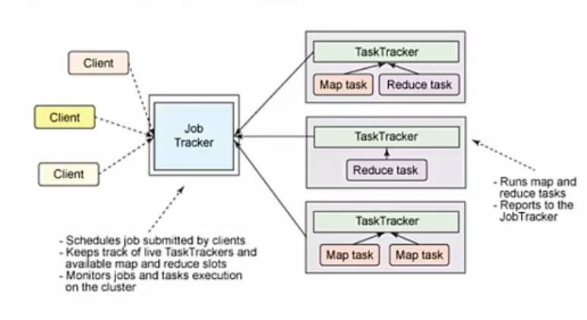

We can see the effect most prominently with the overall job control. In MapReduce v1 there is just one JobTracker that is responsible for allocation of resources and task assignment to data nodes (as TaskTrackers). The TaskTrackers provide ongoing monitoring (through a “heartbeat” sent back to the JobTracter) as each job is run. The TaskTrackers constantly report back to the JobTracker on the status of each running task.

### Yarn Architecture

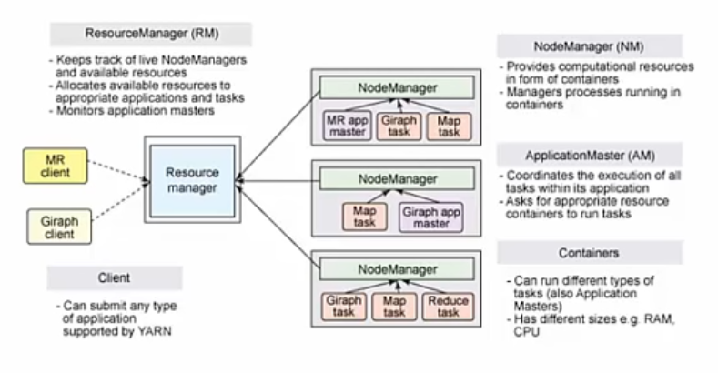

In the YARN architecture,

Global ResourceManager

runs as a master daemon — usually on a dedicated machine — that arbitrates the available cluster resources among various competing applications.

* ResourceManager tracks how many live nodes and resources are available in the cluster
* then coordinates what applications submitted by users should get these resources and when.
* The ResourceManager is the single process that has this information so it can make its allocation (or rather, scheduling) decisions in a shared, secure, and multi-tenant manner (for instance, according to application priority, queue capacity, access control lists [ACLs], data locality, etc.).

#### ApplicationMaster

When a user submits an application, an instance of a lightweight process called the ApplicationMaster is started to coordinate the execution of all tasks within the application.

* This includes monitoring tasks
* restarting failed tasks
* speculatively running slow tasks
* calculating total values of application counters
* These responsibilities were previously assigned to the single JobTracker in the cluster for all jobs.

#### NodeManager

Q) The NodeManager is a more generic and efficient version of the TaskTracker. True or False?

The ApplicationMaster and tasks that belong to its application run in resource containers controlled by the NodeManagers. The NodeManager is a more generic and efficient version of the TaskTracker. Instead of having a fixed number of map and reduce slots, the NodeManager has several dynamically created resource containers. The size of a container depends upon the number of resources it contains and controls, such as memory, CPU, disk, and network IO.

#### Giraph Task

Interestingly, the ApplicationMaster can run any type of task inside a container. For example, the MapReduce ApplicationMaster requests a container to launch a map or a reduce task, while the Giraph ApplicationMaster requests a container to run a Giraph task. You can also implement a custom ApplicationMaster that runs specific tasks and, in this way, invent a shiny new distributed application framework that changes the big data world. I encourage you to read about Apache Twill, which aims to make it easy to write distributed applications sitting on top of YARN. In YARN, MapReduce is simply degraded to a role of just one possible distributed application — but still a very popular and useful one —and is now called MRv2. MRv2 is simply the re-implementation of the classical MapReduce engine, now called MRv1, to run on top of YARN.

### Terminology changes.

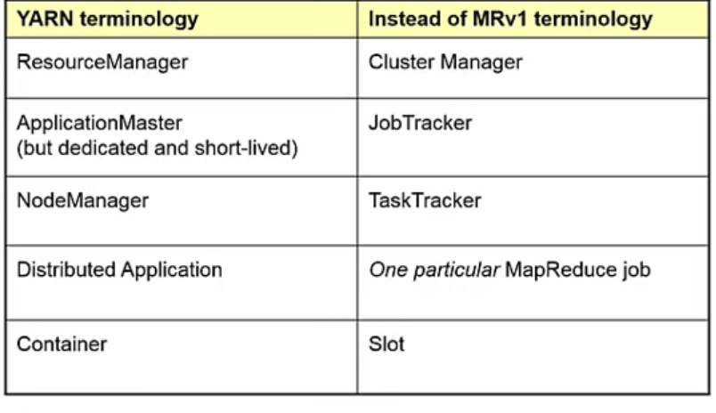

The MR v1 terminology is on the right, the new, YARN, terminology on the left. You have the parallels: Cluster Manager becomes ResourceManager in YARN The singular, but permanent, JobTracker of MR1 become the ApplicationMaster in YARN (but it is dedicated to one job and thus is short-lived) The TaskTracker is replaced by the NodeManager in Hadoop v2 One MapReduce job in MR1 is now a Distributed Application A Slot, which had to be either a Map slot or a Reduce slot is replaced by a generic Container that can be used for many purposes. Containers are the new way of describing a lot of virtual processing approaches these days.

### Yarn in BigInsights

* Yet another resource negotiator
* New resource manager included in hadoop 2.x and later
* Decouples hadoop workload and resource management
* Introduces a general purpose application container
* 2.2.0 includes the first GA version of yarn
* Most venders support YARN

YARN is a key component in the Open Data Platform Initiative and hence in IBM BigInsights v4 BigInsights version 4 is currently based on Hadoop 2.6.0. Other revisions are currently being tested for the OPT initiative. Expect to hear about Hadoop 2.7, etc.

At a high level, we have with YARN a generic resource management environment that can be used as the basis for many different execution and processing engines.

## Configuring, monitoring, and running applications in the YARN environment

You see part of a large cluster. The nodes are numbered 133, 134, etc to suggest this.

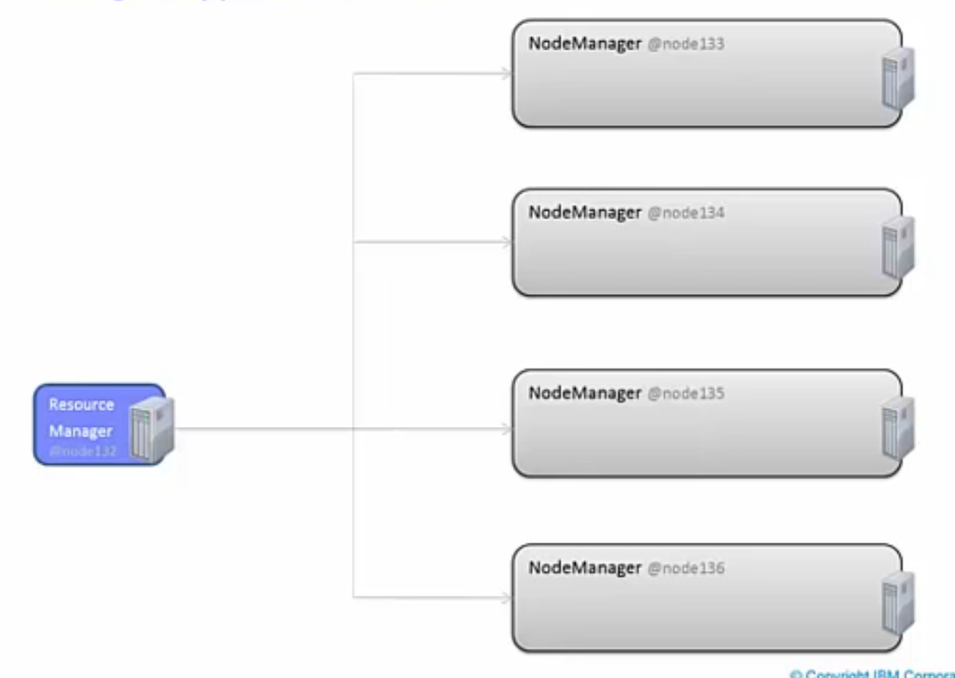

An application — Application #1, since we will have another one shortly — connects to the cluster and wants to start a YARN job. The job is going to analyze line items from various transactions, e.g., a set of invoices.

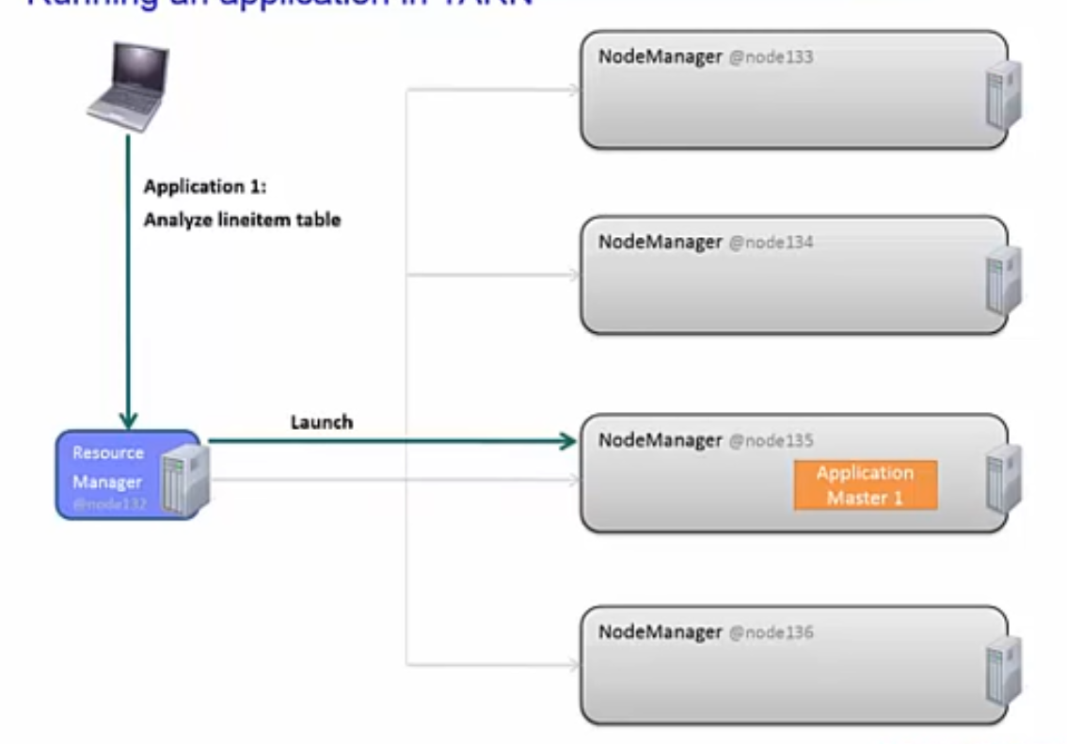

The ResourceManager is contacted. The ResourceManager launches an ApplicationManager that will be responsible for this job. The ResourceManager is permanently running in this cluster; a new ApplicationManager is launched just for this job and will end when the job is complete.

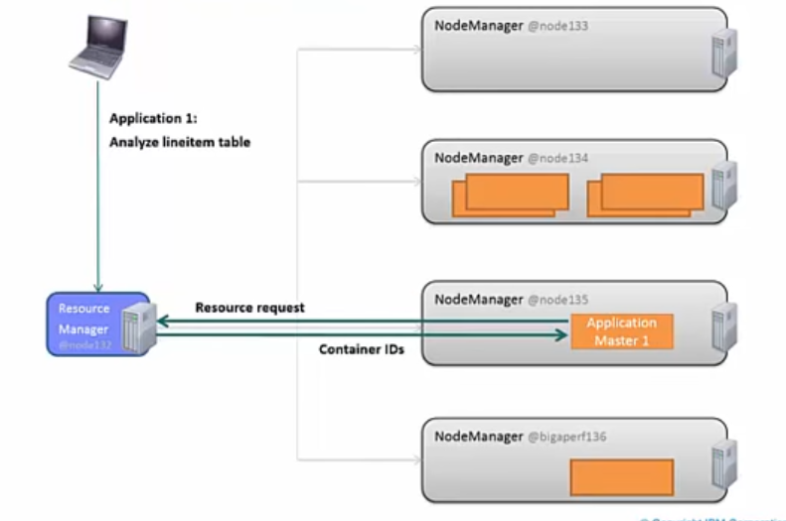

The new ApplicationManager (#1 in this diagram) needs some resources. It sends a resource request to the ResourceManager. The ResourceManager replies by sending the IDs for several containers that have been allocated to this job. This reply message gives the Container IDs, and thereby implies where they containers are available.

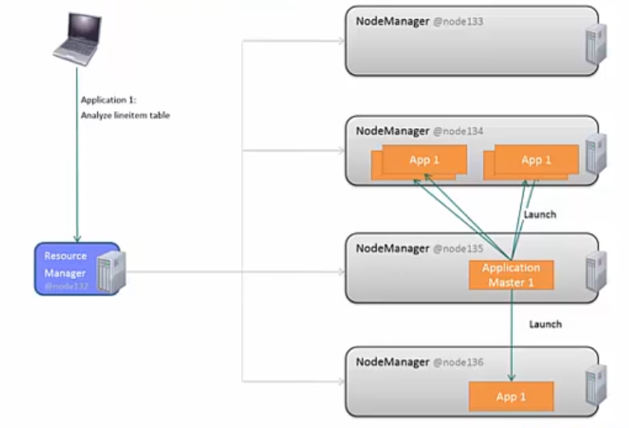

From here on, the ApplicationManager works with, controls, and manages the containers until this job finishes, when this ApplicationMaster finishes as well.

Now let’s see what happens when a second Application (#2) starts to run.

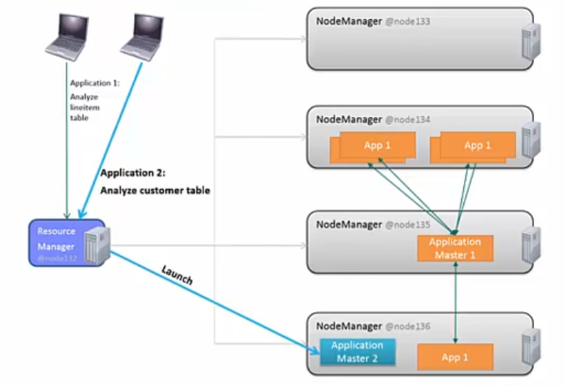

The client program contacts the ResourceManager which then launches a second and new ApplicationManager.

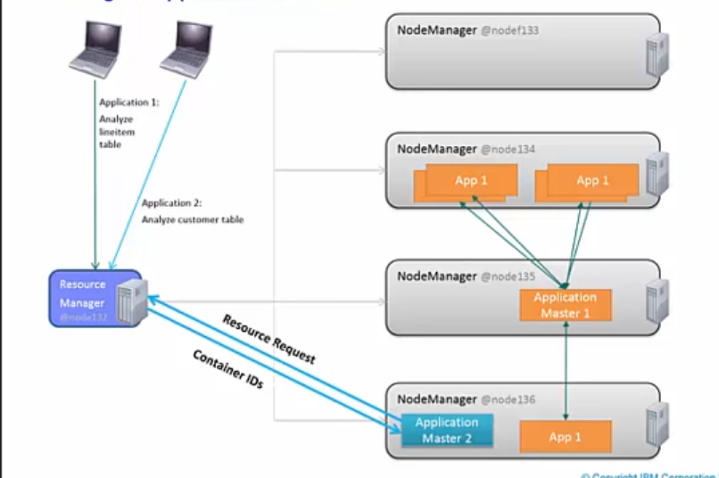

ApplicationManager #2 sends resource requests to the ResourceManager which responds with a list of Container IDs.

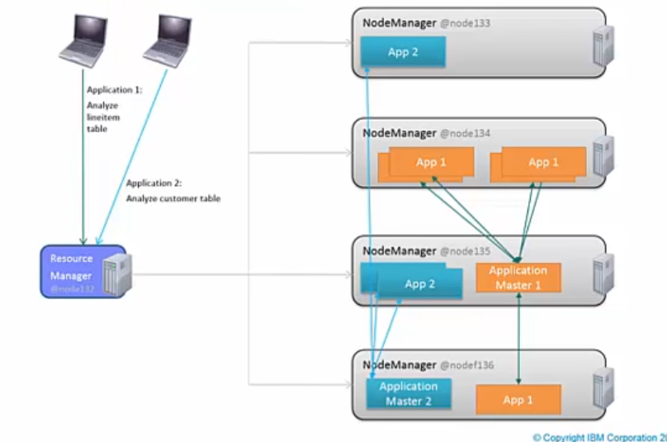

After that, ApplicationMaster #2 works directly with the containers assigned to it.

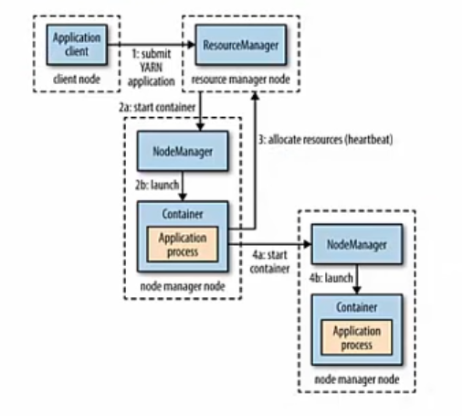

The sequence of steps is summarized numerically in the diagram shown here,

1. To run an application on YARN, a client contacts the resource manager and asks it to run an application master process (step 1).
2. The resource manager then finds a NodeManager that can launch the ApplicationMaster in a container (steps 2a and 2b).
3. Precisely what the application master does once it is running depends on the application itself. It could simply run a computation in the container it is running in and return the result to the client. Or it could request more containers from the resource managers (step 3)
4. And use them to run a distributed computation (steps 4a and 4b).

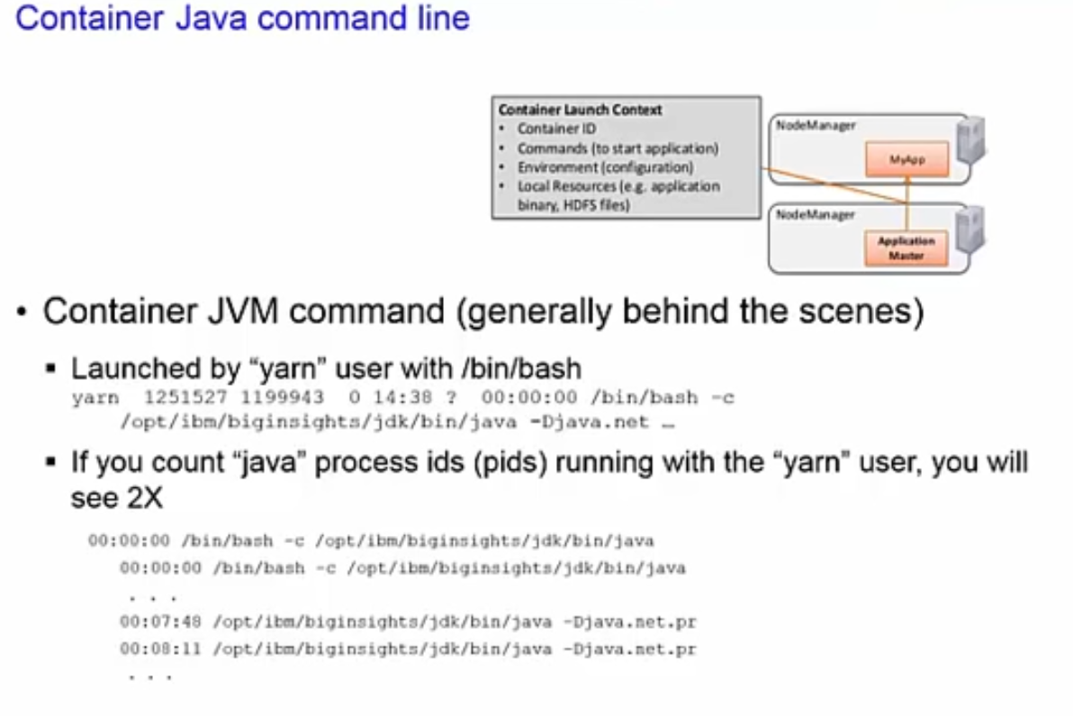

This diagram is not for the faint hearted. It shows some of the factors involved in the Container Launch Context. The information passed includes:

* Container ID
* Commands to start the application
* Environment, i.e., configuration information
* Local resources to be used, e.g., application binary, HDFS file blocks, etc.

When a YARN process is launched, there are two process ids (pids) when you count the processes in Linux.

### Ambari Provisioning, Management, and Monitoring

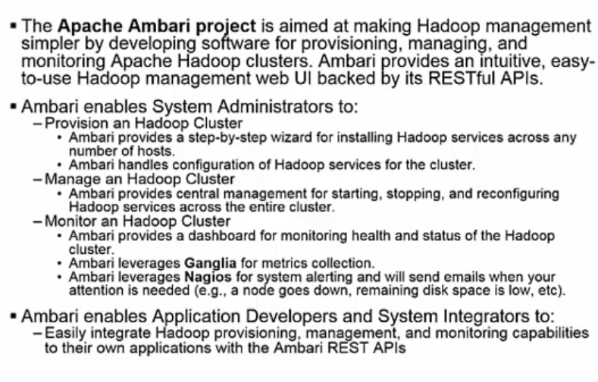

In this slide, we want to remind you of the role of Ambari in Hadoop 2. With Hadoop 2 and YARN there is a greater need to provision, manage, and monitor services because of the greater complexity of the Hadoop 2 environment. Beyond the scope of this course are other services. An important service for a YARN environment is Ambari Slider which provides a mechanism for dynamically changing requirements at run time for long running jobs.

### Spark

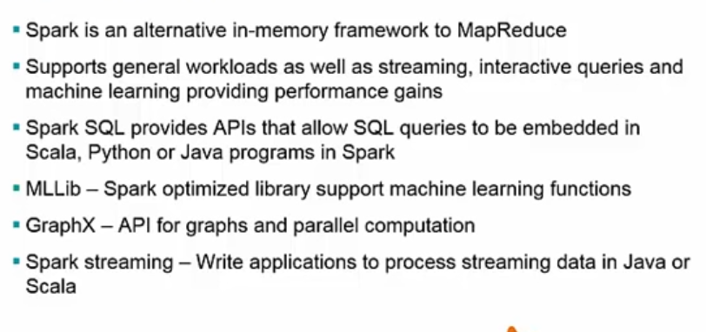

We would be remiss, if we did not mention Apache Spark as Spark is a new, in-memory framework that is an alternative to MapReduce.

# Exam:

1. Which of the following is the correct sequence of MapReduce flow?

Reduce —> Combine —> Map

Combine —> Reduce —> Map

Map —> Reduce —> Combine

Map —> Combine —> Reduce

2. Which of the following can be used to control the number of part files in a MapReduce program's output directory?

Shuffle parameters

Number of Reducers

Counter

Number of Mappers

3. Which of the following operations will work improperly when using a Combiner?

Average

Maximum

Count

Minimum

4. Which of the following is true about MapReduce?

Compression of input files is optional.

Output from the Map phase is replicated.

The programmer must write the Map code, the Shuffle code, and the Reduce code.

MapReduce programs must be written in Java.

Input data to MapReduce is record-oriented and blocks of data contain the same number of full records. True or False?

6. Which statement is true about the Reduce phase of MapReduce?

Output results are sent to the client program.

Data arrives from the Shuffle phase already sorted by key.

The Reducer phase sums up the values associated with each key.

Each Reduce task processes all the data for one key only.

7. Which statement is true about the Reduce phase of MapReduce?

Containers are used instead of slots in MRv1, and can be used with either Map or Reduce tasks in MRv2.

There is one JobTracker in the cluster.

MapReduce jobs written in Java for MRv1 never require recompilation.

Each job has an ApplicationManager that obtains Container IDs from the NodeManager.

8. With YARN, long-running jobs acquire and retain fixed-size containers before execution starts. True or False?

9. Which of the following statements is true?

The NameNode in Hadoop 2 is fully fault-tolerant, whereas in Hadoop 1 it was a single point of failure.

The NodeManager in Hadoop 2 replaces the TaskTracker in Hadoop 1.

YARN requires a minimum of two nodes, one master and one slave, to run

Both MapReduce and YARN can scale to any cluster size.

10. The command athhad∞p provides the CLASSPATH needed for compiling Java programs written for MapReduce or YARN. True or False?

11. Which statement is true about MapReduce's use of replication in HDFS?

Only one copy of each replicated block is processed by MapReduce in normal operation.

Speculative execution is normally performed on all copies of each “split.”

Each DataNode uses RAID to store its data.

Multiple copies of each record are kept on each node.

12. On which file system (FS) is the output of a Mapper task stored?

Linux FS, and it is replicated 3 times.

HDFS, and it is replicated 3 times.

Linux FS, but it is not replicated.

HDFS, but it is not replicated.

13. Which of the following statements is true?

You can set the number of Reducers.

The Shuffle phase is optional.

You can set the number of Mappers and the number of Reducers.

The number of Combiners is the same as the number of Reducers.

You can set the number of Mappers.

14. What will a Hadoop job do if you try to run it with an output directory that is already present?

It will create new files, but with a different suffix.

It will create another directory to store the output.

It will erase all files in that directory before running.

It will not run.

15. What are the main components of the ResourceManager in YARN? Select two.

Scheduler

JobTracker

DataManager

HDFS

ApplicationManager